

KITH & KIN INTERNATIONAL COLLEGE

*7/11 Kaoli Olusanya Street, Owode Ibeshe, Ikorodu, Lagos State.*

**THIRD TERM EXAMINATION 2024/2025 ACADEMIC SESSION**

| **NAME** |  | | | | |
| --- | --- | --- | --- | --- | --- |
| **SUBJECT** | **BASIC SCIENCE** | **CLASS** | **JS2** | **DURATION** | **2 HOURS** |

**SECTION A: OBJECTIVE [20 marks]**

INSTRUCTION: ***Each question is followed by four options lettered A to D. Find the correct option for each question and shade in pencil on your answer sheet, the answer space which bears the same letter as the option you have chosen.***

1. Which part of the flower is responsible for the production of pollen?  
A. Ovary  
B. Anther  
C. Style  
D. Stigma

2. In asexual reproduction in plants, which method involves a part of the parent plant growing into a new plant?  
A. Pollination  
B. Fertilization  
C. Vegetative propagation  
D. Germination

**I**

**II**

**III**

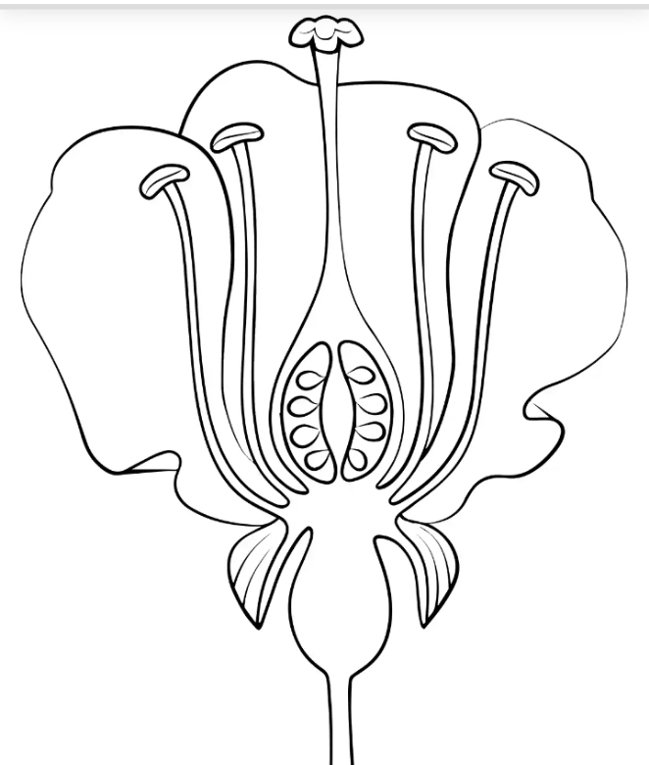

3. The part labeled **III** is the in the diagram above is

A. Stigma

B. Petals

C. Ovary

D. Pedicel

4. What is the function of the part labeled **I**

A. To obtain pollen grain

B. To help in fertilization of ovule to seed

C. To help in fertilization of ovary to fruit

D. To help in storing pollen grain

Use the diagram below to answer question 5

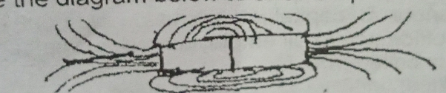

5. A bar magnet has _______ force according to the diagram above

A. Contact

B. Field

C. Magnetic

D. Static

6. A sound wave takes 2 seconds to travel 680 meters. What is its speed?  
A. 340 m/s  
B. 1360 m/s  
C. 680 m/s  
D. 34 m/s

7. Which of the following is an effect of heat energy?  
A. Light reflection  
B. Change in mass  
C. Expansion of materials  
D. Formation of shadow

8. What is the thermal energy required to raise the temperature of 2 kg of water by 5°C? (Specific heat of water = 4200 J/kg°C)  
A. 21,000 J  
B. 42,000 J  
C. 4,200 J  
D. 840 J



9. What type of energy is found in the diagram above ?

A. Thermal energy

B. Sound energy

C. Light energy

D. Mechanical energy

10. Which state of matter has particles that vibrate in fixed positions?  
A. Solid  
B. Liquid  
C. Gas  
D. Plasma

11. Which of the following is a chemical property?  
A. Color  
B. Boiling point  
C. Reactivity with acid  
D. Density

12. Which of the following is not a chemical?  
A. Water  
B. Oxygen  
C. Wood  
D. Hydrogen

13. Which of these is a product of crude oil?  
A. Kerosene  
B. Coal  
C. Wood  
D. Natural gas

14. The process of separating crude oil into different components is known as:  
A. Cracking  
B. Refining  
C. Sifting  
D. Filtering

15. Which of these is a good reproductive health practice?  
A. Sharing sharp objects  
B. Early sexual activity  
C. Abstinence  
D. Drug abuse

16. Which organ is involved in the digestion of food?  
A. Heart  
B. Lungs  
C. Stomach  
D. Kidney

17. The function of the small intestine is to:  
A. Absorb water  
B. Digest food  
C. Absorb digested nutrients  
D. Filter blood

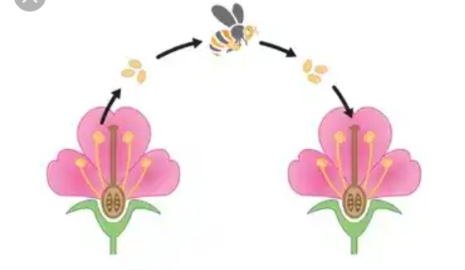

18. What type of pollination is shown in the diagram above?

A. Cross pollination

B. Self pollination

C. Back pollination

D .Crush pollination

19. What is the main waste product excreted by the lungs?  
A. Water  
B. Carbon dioxide  
C. Urea  
D. Salt

20. Which of the following is a sign of puberty in boys?  
A. Menstruation  
B. Breast development  
C. Voice deepening  
D. Widening hips

21. Which of these best defines growth?  
A. Increase in age  
B. Increase in body size and mass  
C. Increase in hunger  
D. Change in behavior

22. A desert fox has large ears. This is an example of:  
A. Reproduction  
B. Camouflage  
C. Adaptation  
D. Evolution

23. Which habitat is best suited for a cactus?  
A. River  
B. Rainforest  
C. Desert  
D. Mountain

24. Which of these is not part of an ecosystem?  
A. Soil  
B. Animals  
C. Weather  
D. Engine oil

25. An example of a decomposer is:  
A. Earthworm  
B. Snake  
C. Lion  
D. Elephant

26. Which of these makes humans unique from animals?  
A. Intelligence  
B. Movement  
C. Eating  
D. Breathing

27. What is rust made of?  
A. Iron and copper  
B. Iron and water  
C. Iron oxide  
D. Carbon dioxide

28. The chemical reaction that forms rust is:  
A. Combustion  
B. Oxidation  
C. Neutralization  
D. Evaporation

29. Which of the following is a reason for abstinence?  
A. To pass exams  
B. To avoid peer pressure  
C. To avoid STIs  
D. To eat healthy food

30. A student lifts a 20 N object to a height of 3 m. How much work is done?  
A. 23 J  
B. 60 J  
C. 6 J  
D. 80 J

31. A boy uses 200 J to push a cart for 5 seconds. What is his power output?  
A. 40 W  
B. 1000 W  
C. 20 W  
D. 10 W

32. What is the unit of power?  
A. Joule  
B. Watt  
C. Newton  
D. Meter

33. A 5 kg object is lifted 2 m above the ground. Calculate the potential energy. (g = 10 m/s²)  
A. 100 J  
B. 50 J  
C. 10 J  
D. 150 J

34. Which of these can negatively affect body image?  
A. Healthy diet  
B. Regular exercise  
C. Social media pressure  
D. Family support

35. Drug abuse can lead to the following except:  
A. Mental health issues  
B. Improved performance  
C. Addiction  
D. Poor judgment

36. Which of these is not an effect of drug abuse?  
A. Aggression  
B. Ill health  
C. Alertness  
D. Death

37. Which of the following is an element?  
A. Air  
B. Water  
C. Oxygen  
D. Sugar

38. Which of these is a compound?  
A. Iron  
B. Carbon  
C. Salt  
D. Nitrogen

39. In the diagram below , heat energy is transferred from the bottom to the top level of water by

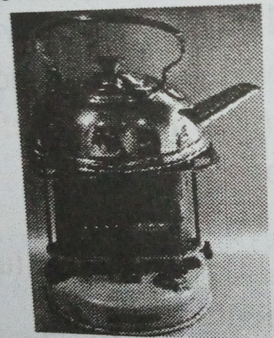

A. Condensation

B. Conduction

C. Convection

D. Radiation

40. Which of these is a method of separating salt from water?  
A. Sieving  
B. Filtration  
C. Evaporation  
D. Decanting

41. A girl pulls a box with a force of 10 N for 4 meters. How much work is done?  
A. 14 J  
B. 40 J  
C. 400 J  
D. 4 J

42. What energy conversion takes place in a microphone?  
A. Sound to light  
B. Light to heat  
C. Sound to electrical  
D. Heat to chemical

43. A mixture of iron filings and sand can be separated by:  
A. Filtration  
B. Distillation  
C. Magnet  
D. Sedimentation

44. Which is a homogeneous mixture?  
A. Air  
B. Sand and water  
C. Oil and water  
D. Iron and sulfur

45. Which of these best describes a compound?  
A. Can be separated by physical means  
B. Made of one kind of atom  
C. Made of two or more elements chemically combined  
D. Cannot be formed in nature

46. How many elements are present in water (H₂O)?  
A. 1  
B. 2  
C. 3  
D. 4

47. The main cause of rusting is:  
A. Sunlight  
B. Salt  
C. Water and air  
D. Fire

48. Which of the following causes pollution in the ecosystem?  
A. Rain  
B. Plants  
C. Smoke  
D. Wind

49. The energy possessed by a moving object is called:  
A. Potential energy  
B. Heat energy  
C. Kinetic energy  
D. Sound energy

50. Which of these is a way to maintain reproductive health?  
A. Sharing razors  
B. Poor hygiene  
C. Abstaining from sex  
D. Using hard drugs

**SECTION B: THEORY (40 marks)**

INSTRUCTION: Answer question number **1** and any other **three (3)** questions in this section. All questions carry equal marks.

1. (a) What is pollination?

(b) Differentiate between self-pollination and cross-pollination.

(c) List two agents of pollination.

(d) Explain the role of the stigma in reproduction.

1. (a) What is a magnetic field?

(b) Describe how to detect the poles of a magnet.

(c) Mention two magnetic and two non-magnetic materials.

(d) State one use of magnets in electronics.

1. (a) Define sound energy.

(b) What is an echo?

(c) State one application of sound in communication.

(d) Explain how sound is transmitted through solids.

1. (a) Define work.

(b) What is power?

(c) A student lifts a 10 kg object to a height of 5 meters in 4 seconds. Calculate:

(i) Work done.

(ii) Power used. (Take g = 10 m/s²)

(d) State the relationship between energy and work.

1. (a) What is the main function of the digestive system?

(b) Name two organs involved in digestion.

(c) State the role of saliva in digestion.

(d) Describe the function of the small intestine.

1. (a) What is reproductive health?

(b) List two ways to care for the reproductive system.

(c) Mention two reproductive organs in females.

(d) State one function of the uterus.